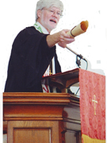

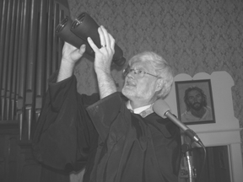
Thursday, February 12, 2009
Lifestyles

West Seneca Bee
Evolution meets God at West Seneca church
FEATURE
Page 17

The Rev. Hope
Harle-Mould shows science, religion
can co-exist.
The Rev. Hope Harle-Mould of St. Peter’s United Church of Christ, 1475 Orchard Park Road, West Seneca, looks to the heavens through his high-powered binoculars. Rev. Harle-Mould uses the binoculars to teach parishioners about the universe.
by TIMOTHY CHIPP

Reporter

Whoever said religion and science don’t mix had no idea that Christians in West Seneca and around the world would someday celebrate evolution and other scientific theories within the walls of a church.
That’s what is happening Sunday, Feb. 15, as members of St. Peter’s United Church of Christ, 1475 Orchard Park Road, celebrate its fourth annual Evolution Weekend.
“About four years ago, I began hearing of evolution weekends being proposed in churches across the country,” the Rev. Hope Harle-Mould said. “It’s designed to let people know that most religious denominations don’t see a conflict between celebrating science and religion and accept evolution as part of how God has made the universe and how our biology works.”
Harle-Mould envisioned and proposed St. Peter’s own Evolution Weekend shortly thereafter, and it has been celebrated ever since.
But this year’s celebration is different because of today’s milestone 200th birthday of the man most synonymous with evolution and church conflict: Charles Darwin.

In addition to the stargazing, Rev. Harle-Mould said Sunday’s service will feature hymns and prayers he has developed for the event.
“We have in our hymnbooks a song that is related to evolution,” he said. “So we’ll sing that. I’ve also written some prayers for the service, which we’ll say.”
Throughout his nine years as pastor of St. Peter’s, Rev. Harle-Mould hasn’t shied from the scientific spotlight. He’s been featured in magazines and other print articles concerning a grouping of stars he found one night while staring at a constellation with his binoculars.

That’s not the only mile-stone being celebrated this weekend. It’s also the 150th anniversary of the release of “On the Origin of Species,” Darwin’s contro-versial book that spring-boarded much of the public debate over Christian beliefs and scientific theories.
“Our tradition encourages us to be people who observe and discover,” Rev. Hope said. “As we observe, we see the inter-connectedness of species and habitats. I want to use this occasion to celebrate what we’ve learned about God’s processes and show how God continues to create.
Sunday’s events include using Rev. Harle-Mould’s binoculars – they’re high-powered lenses, he said – to take a peek at constellations and star formations that make up the heavens. While they’re actually looking at pictures of stars in the heavens,” he said, “the lessons are still the same.”
“God and evolution created the stars and exploded the stars to form the basic elements of the universe, how they coalesced into our solar system,” he said. “So, since we’re stardust creations, we’ll have them look up to the heavens to see where we come from.”
“I called it a mini-constellation, because it was an interesting grouping of stars in a heart-shaped section of the Swan Constellation,” he said. “One thing I try to teach about God and his plan is by explaining that one way we really see more is to see some patterns.”
But celebrating Darwin, a man at the center of church controversy for nearly half his life – and ever since – doesn’t go over well with everyone in his church, Rev. Harle-Mould said.
“Some people have a more fundamentalist theology,” he said. “But most are progressive.

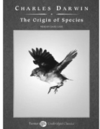
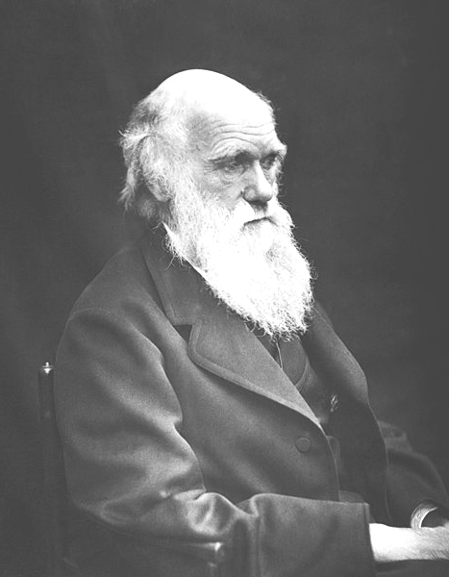
“We don’t have any conflict about doing this. People enjoy that I have a love of science. Part of my job is to show in Scripture how to interpret it in more than just a literal way.”
Once people get past the stigma of learning about evolution in a church, Rev. Harle-Mould said, the rest is easy.
“The more we learn, the more we find out what we don’t know,” Rev. Harle-Mould said. “I want to celebrate all of this and encourage people to keep looking and discovering, as God continues to surprise us. After all, God makes room for quantum mechanics and regular ones, too.”
Further information on Evolution Weekend, St. Peter’s, or the Rev. Harle-Mould can be obtained by calling the church office between 9:30 a.m. and 1:30 p.m. weekdays at 674-1233 or by visiting the church’s web site at www.st-petersucc.org.

e-mail: tchipp@beenews.com
Evolution theorist Charles Darwin would have been 200 years old today, while his most famous book, “On the Origin of Species,” is 150 years old. Keeping that in mind, parishioners at St. Peter’s United Church of Christ will celebrate its fourth annual Evolution Weekend on Sunday.

