The Santa Barbara Independent

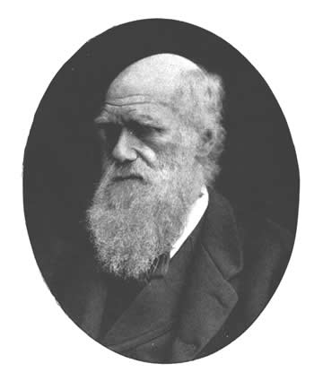

Evolution Weekend

Friday, February 8, 2008
By Elena Gray-Blanc
There’s a strongly felt sentiment, among the deeply religious and the deeply atheistic alike, that science and religion are mutually exclusive — and that a traditional view of God’s creation of the universe is incompatible with scientific theories that have developed concerning life on earth. The recent scandal over the Kansas State Board of Education’s curriculum brought this debate to national prominence.
A group of American clergy, however, take issue with this perceived conflict of views, and in 2005 began something called the Clergy Letter Project. Various clergy wrote letters to state educational agencies, protesting the removal of the theory of evolution from curricula — and the idea caught on. The result was Evolution Weekend, now in its third year, which is observed within some religious communities as a celebration of the possibility of harmonious union between evolutionary theory and religious beliefs.
Understandably, the scientific community has been very receptive to these overtures made by clergy around the nation, and a group of consulting scientists have been added to the ranks of Evolution Weekend supporters. Among these are Mickey P. Rowe, Assistant Specialist in the Neuroscience Institute at UCSB, and Jeffrey P. Schloss, Chair of the Biology Department at Westmont College.
Equally understandably, however, some Christians have taken great issue with the Clergy Letter Project and with Evolution Weekend. A reconciliation of evolution with religion requires a somewhat more symbolic interpretation of the Bible, as opposed to the literal interpretation subscribed to by many Christians. The idea that God gave the spark of life to the world, and then let it go from there — resulting in the evolution of humanity and all other living species — is distinctly at odds with the Book of Genesis, in which God creates Adam and Eve without any intervening steps. While the clergy involved with Evolution Weekend are happy to make this compromise, many others are not. Some clergy have lost their positions as pastors based on their participation in the project, including Rev. Ron Francey, the former pastor of an evangelical church in Michigan.
But despite opposition, there are over 750 congregations taking part in this year’s Evolution Weekend, which will be observed this weekend, from February 8 through February 10. Two churches in our area are participating, Center of the Heart here in Santa Barbara and the First Christian Church (Disciples of Christ) in Lompoc. Anyone in the community, religious, scientific or simply curious, is heartily invited to participate.

