The Orange County Register

Published: Jan. 20, 2010
Updated: 9:18 p.m.

Former priest to discuss evolution, intelligent design
By BRITTANY LEVINE
THE ORANGE COUNTY REGISTER
Story Highlights
UCI professor's Jan. 31 talk at Our Savior's Lutheran Church in San Clemente is intended to demonstrate that science and religion are not adversaries.

A UC Irvine professor and former priest is scheduled to discuss how evolution fits into religion at Our Savior's Lutheran Church and School in San Clemente.
Francisco Ayala will give a lecture called "Evolution vs. Intelligent Design: Darwin's Gift to Religion" from 7 to 8:30 p.m. Sunday, Jan. 31.
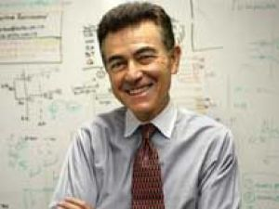
Francisco Ayala, a UCI professor and former priest, will speak Jan. 31 in San Clemente about evolution and intelligent design.
The lecture is an example of a local church working to break down the conflicts between science and religion to foster mutual understanding, Jeff Frohner, a pastor at Our Savior's, wrote in an e-mail. It is part of the annual Evolution Weekend, when about 700 churches across the country plan to host discussions about how science and religion are not adversaries.
The Our Savior's lecture is free and open to the public. The church is at 200 E. Avenida San Pablo. Questions? Call 949-492-6164.
To learn more about Ayala, visit www.faculty.uci.edu.
For more information about Evolution Weekend, go to www.butler.edu.

