Minneapolis Star Tribune

Faithful celebrate and defend Darwin
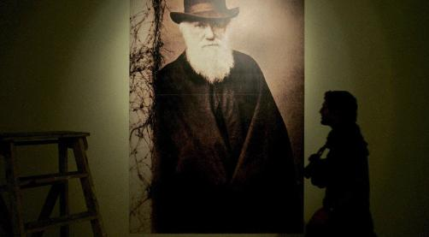
Mario Cruz, Agência de Notícias de Portugal
A part of the Darwin Evolution exhibition in Lisbon, Portugal
On his 200th birthday, many believers went to church to support his theory of evolution.
By JEFF STRICKLER, Star Tribune
Last update: February 12, 2009 - 8:40 PM
Two centuries after Charles Darwin's birth, the argument he started over evolution is going strong -- perhaps even stronger as more churches join the fray.
Nearly two dozen Minnesota congregations are supporting Darwin's case as part of Evolution Weekend, a mobilization effort involving 984 congregations nationwide. Events surround his birthday, Feb. 12.
Members of First Universalist Church in Minneapolis held a birthday party for him. At Mount Zion Temple in St. Paul, Rabbi Adam Spilker will devote Friday's sermon to "the intersections of religion and science." At Southcross Community Church in Burnsville on Sunday, the Rev. Casey VanderBert will pose the question: Do believers have to choose between science and religion? (Sorry-- we promised not to give away the answer.)
Not to be left out, the Minnesota Atheists are holding a panel discussion at 2 p.m. Sunday at Rondo Library in St. Paul.
Don't expect the debate to end any time soon, said David Rhees, executive director of the Bakken Museum.
"I don't know if we're ever going to be finished with this evolution business," he predicted at the "Darwin Day" conference sponsored by First Universalist Church.
"There's still a lot of work to be done grappling with the questions: What does evolution mean to us as individuals? What does it mean to us as a society? And what does it mean to our concept of God?"
Evolutionists 'upped the ante'
Evolution supporters "have become more assertive" after years of battling over the teaching of evolution vs. the Bible's version of creation, said David Masci, a senior research fellow at the Pew Research Center's Forum on Religion & Public Life. "They've upped the ante."
Evolution Weekend is taking heat from the Southern Baptist Church and evangelical mega-churches. While local groups including the Twin Cities Creation Science Association take issue with Darwin's theories, they've decided to keep a low profile this weekend, let the Darwin buzz run its course and hope everything returns to normal on Monday.
Chances are that will happen.
"The only thing not evolving is the debate over evolution," Masci said. "That's because it deals with core values. It's about what you believe in."
'Theist evolution' evolves
Led by the Roman Catholic Church, many denominations outside the Bible Belt embrace what is called "theist evolution," which holds that evolution took place under a higher power. This theory is endorsed by, among others, Episcopalians, Presbyterians, Methodists and the Evangelical Lutheran Church in America.
"It allows that man's soul, man's consciousness, was the divine creation of God," Masci said. "That was a major issue for people who objected to the notion that mankind was created entirely at random."
Nonetheless, the debate grows. Countless school board meetings have been consumed by arguments over whether creation theories should be taught along with -- or even in place of -- evolution.
"Religion got tangled up with science, and then they both got tangled up in politics," said the Rev. Kate Tucker of First Universalist Church.
Ken Waters, a philosophy professor at the University of Minnesota who was part of the Darwin Day conference, warned that misdirected questions can sidetrack the debate.
"If you want to know the meaning of life, science is not going to give you the answer," he said. "We have to draw a line between what science compels us to believe and what it leaves optional. Science leaves a lot of beliefs optional."
Jeff Strickler • 612-673-7392

