KXAN Television: Austin, Texas
15 January 2009

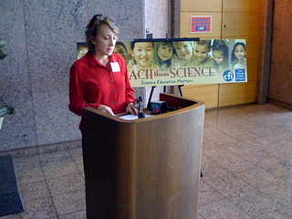
Teach Them Science press conference

Web site helps children
learn science

Hopes to encourage new science ed.
standards
Last Edited: Thursday, 15 Jan 2009, 1:43 PM CST
Created On: Thursday, 15 Jan 2009, 1:41 PM CST
- Blair Shiff
AUSTIN (KXAN) - The Center for Inquiry and the Clergy Letter Project came together to ensure Texas children's science education stays up to date, in their opinion. The Texas State Board of Education is currently determining the science curriculum for the next decade.. A committee of teachers and scientists planned new standards, which they feel will help Texas children stay competitive in the scientific community. The board controls textbook content, which can influence children's education in a certain subject.
The Teach Them Science Web site tackles the controversial subject of evolution versus creationism in science education. The site feels that around half of the SBOE prefers to teach how to argue against evolution, which they find to contradict scientific thinking. The site, obviously, is in support of evolution education instead of just teaching creationism.
The initial vote on the new science curriculum standards will be on Jan. 21-23. The final vote will be in March 2009. The Web site has an area where people can get involved with their case and support new textbook content.
Let us know what you think about science education in Texas by participating in our message board .

