Grand Rapids Press

Lincoln, Darwin change history, religious thought

by Charles Honey | The Grand Rapids Press

Saturday February 14, 2009, 6:29 AM
When the English biologist Charles Darwin published "The Origin of Species by Means of Natural Selection" in 1859, the former theology student knew his theory of evolution would cause a scientific and religious uproar. He confided to family and friends it was "like confessing a murder."
But within two years, President Abraham Lincoln saw a military corollary of Darwin's theory play out as the North's superior firepower vanquished Southern soldiers: survival of the fittest on ruthless display.
While Darwin studied finches and fossils, the bones of dead Americans provided a grisly case study of what later became known as social Darwinism, says one historian.
"Once Darwin became known, (people) could look back at the Civil War and say, 'That's the laboratory. You can see it happen,'" says James Bratt, professor of religious and intellectual history at Calvin College.
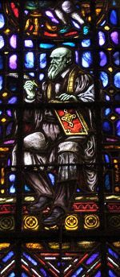Press Photo/Emily ZoladzCharles Darwin is featured in the Wisdom Window on the west wall of Fountain Street Church.
Meanwhile, Lincoln surveyed the bloody laboratory and, in his 1865 second inaugural address, invoked a mysterious yet merciful God by quoting Psalm 19: "The judgments of the Lord are true and righteous altogether."
"He was not a Christian by most measures of the term," Bratt says. "And yet he gives a more Christ-like expression of forgiveness and humility than virtually all the pulpiteers around him."
Rare courage
Lincoln and Darwin: They seem to have little in common other than both were born on Feb. 12, 1809. But they also are linked by bold ideas and rare courage that profoundly changed history -- and continue to influence American culture.
This week, the bicentennials of these historical giants brought forth tributes from churches as well as universities and civic groups. Both men grappled with faith and doubt amid immense change, leaving rich legacies for religious thought and how it functions in society.
"Here you have in one day the celebration of two people who had different ideas and provided us with two different metaphors to understand community," says the Rev. Brent Smith, pastor of All Souls Community Church in Grand Rapids.
Smith's Unitarian Universalist congregation honored Lincoln Sunday with readings from the Gettysburg Address and his second inaugural address.
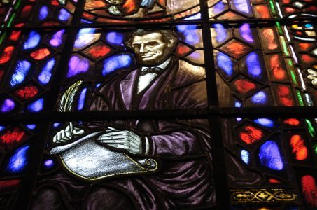Press Photo/Emily ZoladzAbraham Lincoln is featured in the Freedom Window on the northwest wall of Fountain Street Church.
Lincoln and Darwin shared a commitment to reason and realism but had very different ideas about human community, Smith says. Where Darwin saw humans as part of "an evolving living organism," Lincoln saw a covenant community based on rights transcending human institutions.
"If African slaves are human beings, then they have rights, and they're given by God and not the government," Smith said.
He sees Lincoln's legacy continuing today in President Barack Obama, who has utilized Lincoln's example as he faces national crises.
"I think this is what Obama understands about Lincoln," Smith said.
"The human condition is tragic, but there is a providence that shoots through human existence that is redemptive."
Evolution Weekend
His church also will recognize Darwin Sunday as part of an "Evolution Weekend" being observed by close to 1,000 churches nationally. Smith is one of more than 12,000 signers of the Clergy Letter Project asserting that biblical truth and modern science "may comfortably coexist."
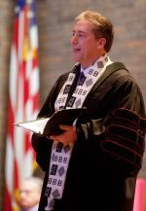Press Photo/Adam BirdThe Rev. Dr. Brent Smith talks Sunday to the congregation at All Souls Community Church about Abraham Lincoln.
Darwin's birth also is being celebrated by Michigan's Center for Inquiry and other nonbelievers marking his evolution revolution. But there's no celebrating among religious conservatives pushing for God-inclusive creation theories in classrooms.
Despite polls showing close to half of Americans reject evolution, some see fears fading that Darwin threatens Scriptural belief.
"God did it, Darwin described it," sums up the Rev. Ian Lawton, pastor of Christ Community Church in Spring Lake, which Sunday culminates a three-week series on science and religion. "God's behind (creation), Darwin neatly described the patterns of it, and those patterns are wondrous."
Lawton sees wonder in Darwin's elegant explanation of nature's complexity as well as timely truth in his placing humans in a broader environmental context. His theory of ever-evolving life resonates more powerfully than ever, Lawton argues.
"Particularly at a time like this when there's a lot of crisis in the world, the thought that there are always second chances, there's always more to be understood -- that's a very hopeful, encouraging message," Lawton says.
Darwin's message often is misunderstood by those who see his theories threatening religion, says Gregory Forbes, director of the national Evolution Education Institute. Forbes notes Darwin graduated from Cambridge with a degree in theology and originally wanted to be a parson.
Darwin agonized over the religious import of his discoveries, taking 25 years to publish "Origin of Species." But even then he wrote the "grandeur" of creation was "originally breathed by the Creator." He died an agnostic, not denying God's existence but concluding it could not be proved or disproved scientifically, Forbes said.
Door to modern thought
Darwin's theory destroyed scientific and religious dogma, opening the way for modern thought, adds Forbes, a biology professor at Grand Rapids Community College.
"Darwin stood up and said, 'It's OK to think outside the box.' That's what we value in Western culture."
Calling evolution "the most well-substantiated theory science has ever seen," Forbes said it pervades society from medicine to marketing.
"As the marketing environment changes and you do not, you become extinct," Forbes says. "GM should know."
But pervasive though it may be socially, evolution as a biological theory continues to meet stiff resistance. The Louisiana legislature last year ruled public school teachers could teach alternative theories.
Debate about evolution is about more than religious defensiveness, says Nigel Crompton, a biology professor at Cornerstone University. Crompton argues natural selection can explain evolutionary adaptations in simpler life forms, such as birds, but not in larger biological systems and humans.
"He got it right to a certain extent," Crompton says of Darwin, but adds, "I personally think God created man."
Crompton also worries evolutionary theory has encouraged "reductive" thought that sees living things as the sum of their parts. That's like "trying to understand Shakespeare based on the letters," he says.
"If you do not feel there is some kind of God or designer behind the created order, then you stop seeing meaning behind that," Crompton adds.
Darwin's biological theory transformed over time into a social theory that he never intended, says Calvin College's Bratt.
"How people interpreted what he taught about the natural world got applied to the social world in a way that warranted hard-knuckle, capitalist industrialization," Bratt says.
That way of thinking was not too far from Lincoln's, who favored government backing big business to promote progress, Bratt says. Like Darwin, he had a materialist view of life in his younger days and not much spirituality.
But America's trials shaped his religious views. Though he did not believe in the divinity of Jesus -- his wife, Mary, said he was religious but "not a technical Christian" -- Lincoln used political speech that was "deeply saturated with religious language," Bratt says.
Religious imagery pours through his second inaugural address and its prophetic phrase, "With malice toward none; with charity for all; with firmness in the right, as God gives us to see the right, let us strive to finish the work we are in."
"That call to humility and mercy in the second inaugural is the best American civil religion can do," Bratt says.
Lincoln's assassination on Good Friday is a powerful symbol of his role in our history, Bratt adds.
"He is the dying Messiah of the nation. He redeemed the nation of its original sin, slavery. In his death, he brings the separated parts of the nation together."
E-mail Charles Honey: choney@grpress.com

