
Maryland Community Newspapers Online

Wednesday, Feb. 14, 2007

The ‘Evolution’ of progressive religions

Seekers Church leader draws from faith and science for discussion in honor of Darwin’s birthday
by Agnes Jasinski | Staff Writer

The Rev. Pat Conover isn’t a scientist, but he has become well read in the discipline.
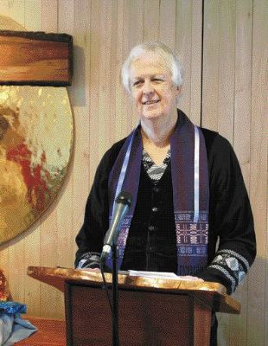
Meredith Suniewick⁄Special to The Gazette
The Rev. Pat Conover, a longtime Takoma Park resident and member of the Seekers Church, stands at the pulpit of the Takoma, D.C., church.
View all ads
When he volunteered to give a sermon and lead a discussion exploring how evolutionary theory and Christian values can coexist, he drew from his own beliefs on the philosophy of science and his own interests in bringing those ideas to what he feels is a more open-minded community than most.
The discussion was part of a national movement titled ‘‘Evolution Sunday,” as churches across the country met to discuss differing opinions on the role science plays in theology. This was the first time Conover’s congregation, the progressive Seekers Church in Takoma, D.C., hosted the event, and only the second time it was held nationwide.
‘‘It was good just that it happened,” said Conover, a Silver Spring resident who has been a member of Seekers for the last 20 years. ‘‘I’m pleased that there were religious folks interested who hadn’t thought much about evolution.”
More than 500 churches participated in Evolution Sunday, planned to coincide with evolution theorist’s Charles Darwin’s birthday Monday.
Conover’s sermon was based on the first 12 verses in the Bible’s Book of Genesis, which he said explores such ideas as survival, reflection and an appreciation for life.
‘‘Science’s province is helping us understand how we came into being, and how life has changed,” he said. ‘‘We know from science how God brought life into existence.”
Conover was born in Washington, D.C., but grew up in Tallahassee, Fla., with an Episcopalian mother and a Congregationalist father in what he called a religiously ‘‘diverse” household. He had always been drawn to alternative Christianity and innovative expressions of mainstream religions, and explored those ideas at the Chicago Theological Seminary.
After receiving his Master of Divinity degree at the seminary, he went to Florida State University for his doctorate in sociology, when it became clear he was becoming more interested in science and ‘‘how people form institutions,” he said.
Conover said he knew about Seekers Church long before he moved back to the D.C. area. In 2002, he published a book with the help of a grant from the church titled ‘‘Transgender Good News,” which looked at the transgender experience through a Christian perspective.
For 40 years, his ‘‘day job” was as an ordained minister in public policy advocacy for the United Church of Christ. But Seekers Church remained his passion. His wife, Patricia Nemore, is also a member of the church, which is based on the traditions of the Church of the Savior. The Church of the Savior is a nondenominational church that places heavy emphasis on mission work and looks beyond ‘‘Biblical Christianity,” according to its Web site.
‘‘What’s blossoming right now is progressive Christianity ... it’s rising up from the grassroots, and that’s very exciting,” Conover said. ‘‘Seekers is a congregation where no one is afraid of scientific truth.”
Richard Lawrence, a member of Seekers Church from Falls Church, Va., agreed.
‘‘The climate there is one of honesty and openness to competing ideas,” said Lawrence, who added that although he had a ‘‘solid Baptist background,” he has always found it natural to accept science into his beliefs. Lawrence was also the founder of the grassroots ‘‘Message Group,” which eventually became the Arlington, Va.,-based Alliance for Science, a group concerned with protecting the teaching of evolution in the public school system.
‘‘It’s important to reach out to religious communities, and make them understand that they don’t have to be threatened by science,” said Greg Tinkler, a board member with Alliance for Science.
Conover said he hopes to see Seekers Church or a progressive congregation in the area host Evolution Sunday again next year, and expand on themes they introduced in the hour of discussion Sunday.
‘‘People really need to just let science be science,” he said. ‘‘The tragedy is that we’re locked in a culture war... there’s enough room to be in constructive conversations.”

