Chicago Public Radio WBEZ 91.5 FM
Darwin's Birthday Brings Unique Celebration
Produced by Lynette Kalsnes on Saturday, February 13, 2010
Churches and synagogues across Chicago are celebrating Darwin's birthday this weekend.
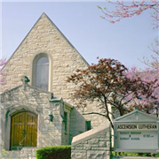
Photo via Ascension-Riverside.org
Pastors and rabbis are delivering sermons and holding workshops related to science.
Pastor Roger Timm of Ascension Lutheran Church in Riverside says he's taking part in national Evolution Weekend to help overcome the fear of science.
TIMM: I find it disturbing that the world has the attitude that is kind of perpetuated by some scientists and religious people that faith and science must be in conflict and that you cannot both use the theory of evolution and believe in God as creator in some sense.
One of the scientists, Adler Planetarium astronomer Grace Wolf-Chase, says people don't have to choose between faith and science.
WOLF-CHASE: By studying how the universe comes to be, how new things arise in nature, I don't speak to the question of purpose.
She leaves that for religion.

