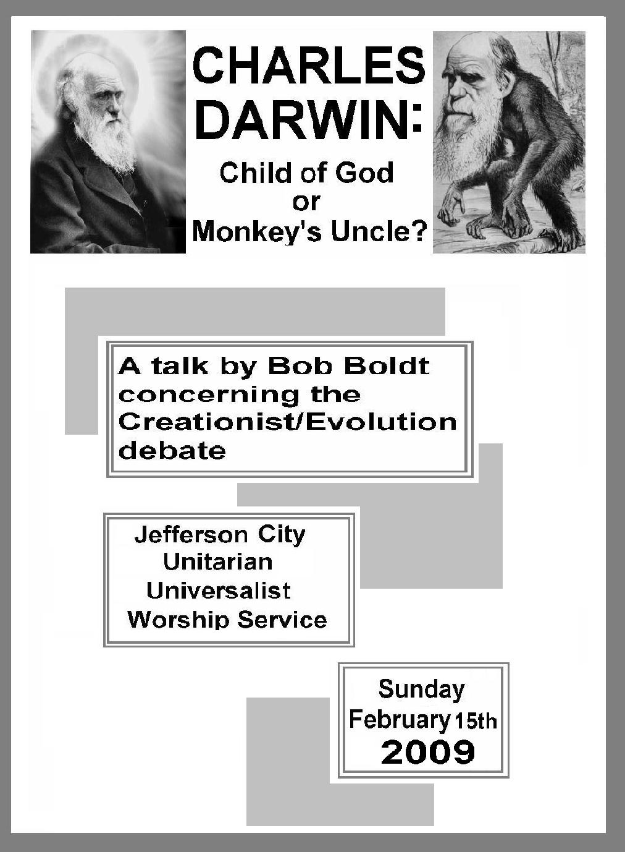

A few facts must precede my remarks. First of all is the apparent coincidence of the birthdays of two of the most influential men of the nineteenth Century. Abraham Lincoln and Charles Darwin were both born on the same day (February 12th) of the same year in 1809. Some choose to consider this evidence of some remarkable causation, whereas others would call it mere coincidence. Nevertheless this year we celebrate the two-hundredth anniversary of the birth of these two remarkable men who, each in his own arena, advanced the cause of human freedom. This Sunday I choose to focus on issues surrounding discovery of the mechanisms of biological evolution. Darwin’s seminal work, “On The Origin of Species,” published in 1859 has, along with the work of Karl Marx and Sigmund Freud, literally revolutionized our thinking and helped inaugurate the modern age.

We, along with over a thousand other congregations in some 14 countries around the world, are today celebrating Darwin Sunday, an event hosted by the Clergy Letter Project which is attempting to understand and promote the harmony that exists or should exist between science and religion.

I am not going to spend a lot of time this morning reviewing Darwin, his amazing life and history and his Theory. The ideas presented in his “On The Origin of Species” were so brilliant, so insightful, so prescient and have held up so well to subsequent scrutiny that, were I not so predisposed toward my own unorthodox form of atheism, I might actually consider them divinely inspired. I am instead going to devote my remarks primarily to the struggle of a small minority of the religious community to defame and defeat Darwin and to trash his incalculable contributions to human knowledge.

Some fundamentalist Christians do not greet this great leap of insight and understanding that began with Darwin as anything but a disaster. They blame every social and moral ill of modern society on the Theory of Evolution. Salman Rushdie said in an interview with Bill Moyers that, as a young man in the sixties, he believed that the thought that religion would become the center of public life seemed unthinkable. He believed religion would be relegated to the margins of the public and political stage instead of the way it is today.

In this country, we have largely the fundamentalist religious right to thank for the theologically and politically contentious, toxic social atmosphere that has so dramatically polarized our country and nearly all its institutions. For the past two decades there has been an increasingly vehement attack on science in general and biological evolution in particular. Those who attack evolution are small in number and have little scientific or academic standing but make up for their lack of light with the generation of an inordinate amount of heat.

I have spent a certain amount of time examining the contentions of the fundamentalist, religious right, their assumptions and assertions:
- A divine, miraculous intervention by a Supreme Being is the only explanation for certain mysteries such as the origin of the universe and the creation of the earth.
- This Supreme Being who should always be addressed as “He” (male gender) is the creator of all life and all the specially created, diverse species (no transitional forms, thank you.)
- Homo Sapiens were placed by Him at the apex of creation. We were the most specially created of all and are wholly unrelated to other creatures.
- Man was given dominion over all other life forms and all the earth’s resources by a Divine Mandate.
- The Bible is the final authority in all things concerning ethics, history, cosmology, and science. Since the Bible is the divinely inspired word of God, it contains no error. It must be taken literally. All evidence from materialistic science that appears to contradict the Bible is in error and must be harmonized with Holy Writ.
- There is incontrovertible evidence that evolution is, not only fundamentally incorrect, but that it represents a concealed Satanically inspired agenda (I kid you not) whose goal is to create a society of atheistic, morally corrupted people who will serve the Dark Lord.

Now you don’t hear these extremist views expressed in most public debates in which the Creationists participate. A cleverly constructed Trojan Horse, called Intelligent Design, has been proposed to give the appearance of intellectual respectability and hide the fact that ID is essentially a theological construct. Nevertheless, within the belly of this beast beats the heart of the fundamentalist teachings of Creationism.

It can be quite troubling for a layman, who may have only a general knowledge of science, to confront the Creationist teachings that would deny the commonly accepted ideas of geologic time and the evolution of life on the planet. It is essential to understand exactly where the Creationist’s arguments are coming from, what motivates them and the assumptions upon which these arguments are based.

The 2005 Kitzmiller v. Dover PA Area School District decision struck a mortal blow against the forces that would have created a major breakthrough in their attempts to teach Creationism in public school science classrooms. Without going into too much detail, the Dover, PA school board mandated that a statement be read to the ninth-grade science classes to the effect that Intelligent Design is a theory on parity with Evolution and pointing out that a text called “Of Pandas and People,” published by the Discovery Institute was available to students to explain the concept of Intelligent Design. The case was a disaster for those who wanted to teach a religious alternative to accepted science.

Many interesting facts about the Creationist strategies were revealed in the course of the trial. One was that Intelligent Design was really not any different than Creationism (a theological concept Constitutionally prohibited in public school schools under the separation clause). The Discovery Institute, who promoted “Of Pandas and People,” had actually changed the word “Creationism” to “Intelligent Design” in order to skirt the provisions of the Supreme Court decision of 1987 prohibiting the teaching of religion in the public schools. Henceforth ID can only be known as promoting the idea of God or the Intelligent Designer—a supernatural religious concept prohibited by both the Supreme Court and the tenets of Science.

Now what’s wrong with believing that there was some supernatural agency that created the universe, hung the stars like lamps in heaven and specially created each creature exclusively after its own kind?

I must say that many believe this. Many choose to believe literally the Genesis story. Personally I feel that a non-metaphorical analysis of Genesis yields a rather bizarre, illogical view of creation, especially in light of what the science tells us of cosmology.

Creationists attack some of the most commonly accepted scientific ideas. Their Young Earth Theory would have us believe the earth is actually the result (literally) of a 24 hour-day, six-day process. They assert that the earth, from the first of those days to the present contains the span of only some six thousand years. How do they know? ‘Cause the Bible tells them so—that and the fact that carbon dating is not valid. They challenge the large evolution theory that explains the creation of new species from old by way of “missing links,” but allow that some micro-evolution within species may have taken place. And of course they deny the common ancestry of all creatures from less complex organisms, asserting incorrectly that there is no evidence of transitional forms. Above all, the Creationists insist man is a special creation, he does not spring from so called lower forms and the evidence of shared physiological similarities (and even DNA) with other primates and other creatures is explained away as merely evidence of God using good design ideas that He perfected (?) in His creation of separately created, pre-existing lower forms. Tell a person with fallen arches or a bad back or a woman experiencing a breach delivery of the wonderful, flawless design of God’s special creation! Perhaps most interesting of all is the Creationists’ challenge of natural selection as the mechanism responsible for the development of “… forms most beautiful and most wonderful (that) have been, and are being, evolved.” – Darwin. They say that mere blind natural selection alone cannot possibly explain all the extremely complex manifestations of organic forms and mechanism—from the nearly infinitely complex DNA molecule, to the human eye, and to Michael Behe’s poster child for irreducible complexity, the bacterial flagellum.

I wish it were possible to discuss in detail all the Creationist’s convoluted arguments against science here. I must admit that some of these arguments sound compelling. They are quite fond of stating, for example, that it is impossible to understand a creation without a creator, in the same way that you cannot understand a watch without positing the existence of a watchmaker. The DNA molecule is so complex that it could not possibly have evolved. It is (according to Creationists) an irreducibly complex structure. They are fond of stating that it is more likely that a tornado, blowing through a junk yard, would naturally select all the required parts and assemble them in the right order to create a 747 than the DNA molecule could be assembled by materialistic natural causes alone.

Some secular-Christians counter by hypothesizing a Divine Agent, who sort of nudges nature to make the right choices out of an otherwise equally random series of options. This is a variant of the old idea that God manifests his will through the mechanism of evolution. This seems as comic as the king in Saint Exupery’s Little Prince who orders the sun to rise each morning. This of course is essentially yielding to the Creationist argument. I don’t really give much credence to Christian Evolutionists. I think they are just hedging their bets and attempting to bridge the gap between two irreconcilable positions.

I think the Creationist argument against evolution can be quite simply resolved by the following statement:

Science cannot consider any supernatural agency in formulating its explanations of the natural world.

At any moment there are nearly an infinite number of phenomenon science cannot explain. For every discovery a new series of unexplained unknowns is revealed. What is known in science always rests on the shifting sands of doubt. Unlike the clergyman, the scientist is not setting out to stamp out all doubt. For science, doubt is its greatest strength.

Jacob Bronowski, scientist, poet, film producer, science historian and William Blake scholar, hosted the 1973 groundbreaking BBC science documentary, The Ascent of Man, This eloquent passage from the series, sums up the dangers of the kind of dogma, absolutism, arrogance and certainty that is so prevalent in Creationist thinking and in Biblical literalism.

"The Principle of Uncertainty is a bad name. In science--or outside of it--we are not uncertain; our knowledge is merely confined, within a certain tolerance. We should call it the Principle of Tolerance. And I propose that name in two senses: First, in the engineering sense--science has progressed, step by step, the most successful enterprise in the ascent of man, because it has understood that the exchange of information between man and nature, and man and man, can only take place with a certain tolerance.
But second, I also use the word, passionately, about the real world. All knowledge--all information between human beings--can only be exchanged within a play of tolerance. And that is true whether the exchange is in science, or in literature, or in religion, or in politics, or in any form of thought that aspires to dogma. It's a major tragedy of my lifetime and yours that scientists were refining, to the most exquisite precision, the Principle of Tolerance--and turning their backs on the fact that all around them, tolerance was crashing to the ground beyond repair.
The Principle of Uncertainty or, in my phrase, the Principle of Tolerance, fixed once and for all the realization that all knowledge is limited. It is an irony of history that at the very time when this was being worked out there should rise, under Hitler in Germany and other tyrants elsewhere, a counter-conception: a principle of monstrous certainty. When the future looks back on the 1930s it will think of them as a crucial confrontation of culture as I have been expounding it, the ascent of man, against the throwback to the despots' belief that they have absolute certainty.
It is said that science will dehumanize people and turn them into numbers. That is false: tragically false. Look for yourself. This is the concentration camp and crematorium at Auschwitz. “This” is where people were turned into numbers. Into this pond were flushed the ashes of four million people. And that was not done by gas. It was done by arrogance. It was done by dogma. It was done by ignorance. When people believe that they have absolute knowledge, with no test in reality--this is how they behave. This is what men do when they aspire to the knowledge of gods.
Science is a very human form of knowledge. We are always at the brink of the known; we always feel forward for what is to be hoped. Every judgment in science stands on the edge of error, and is personal. Science is a tribute to what we can know although we are fallible. In the end, the words were said by Oliver Cromwell: "I beseech you, in the bowels of Christ: Think it possible you may be mistaken.
We have to cure ourselves of the itch for absolute knowledge and power. We have to close the distance between the push-button order and the human act. We have to touch people."

Jacob Bronowski, "Knowledge or Certainty" episode from the 1973 BBC series "The Ascent of Man"

My primary concern in the great Evolution/Creationism Debate is not the strength of the Creationist position either logically or politically, it is the cowardice and the complacency of both the scientific/academic community and the main-stream secular-Christian congregations. Neither has been at all proactive in countering the massively financed media and PR campaigns of the fundamentalist Christians. These people may be ignorant but they are not stupid. What they lack in scientific understanding they more than make up for in promotional acumen. Their goal is nothing less than the banishment of the teaching of science from the classrooms of every public and private educational institution in this country, enforced by a fascist, theocratic United States government. These people are not to be laughed at because they are well financed, determined and will use any means, fair or foul to accomplish their goal. They believe that Jesus Christ, Himself is behind them and their lies. These people are not likely to grow weaker in light of today’s deepening social and economic crisis.

Today we face two vital challenges that will literally determine the fate of all the occupants of our little blue boat.

The first is how we deal with an end-time crisis. I am referring not to the end-time of the religious fundamentalist apocalyptic fantasies, but the massive failure of our culture, institutions and markets in a world that has passed the carrying capacity of the planet to tolerate the human influences that threaten to end all life.

Adlai Stevenson once said, "We travel together, passengers on a little spaceship, dependent on its vulnerable resources of air and soil; all committed for our safety to its security and peace; preserved from annihilation only by the work, the care and I will say the love we give our fragile planet."

The second challenge we face is how we will create a story, a modern myth if you will, that incorporates a survival strategy for planetary life that meets our need to reconcile science with our neurophysiology that is hardwired to seek the Divine.

Ideas have consequences quite independent of their veracity. For example, you will behave in a very self-destructive way if your story tells you that your purpose in life is to conquer nature, that you stand quite apart from the natural world and that you were created uniquely above nature and that nature is created and designed exclusively for your own life and pleasure.
“And God blessed them, and God said unto them, Be fruitful, and multiply, and replenish the earth, and subdue it: and have dominion over the fish of the sea, and over the fowl of the air, and over every living thing that moveth upon the earth.”

Genesis 1:28 (King James Version)

Who could have predicted that, by our obeying this command, we would turn the earth into an overpopulated dung heap? I leave it to theological speculation to determine whether that particular benighted demiurge was granting a blessing or a curse on mankind.

Compare that to a system that views nature as an organic whole with man as an integral part of the ever-evolving universe.

On December 7, 1972, humanity saw the first view of the Whole Earth as photographed by the crew of Apollo 17 at a distance of 18,00 miles out in space. The impact of this picture was world-shaking. On a conscious level it was a celebration, a confirmation of president John F. Kennedy’s expressed dream of space travel, first envisioned eleven years earlier. This unique whole earth view was something previously not in the conceptual vocabulary of realistic thinkers—more the fare of fantasy and science fiction writers. The true impact of this picture was to be found on a deeper unconscious level however. It forged a new concept, a new way of seeing. The baby finally had glimpsed its mother for the first time. Partially as a result of his work with NASA, James Lovelock coined, or rather revived, the concept of Gaia: The earth as a conscious entity, a goddess if you will. This image, born of technology, was to become the new banner of a story of wholeness for a whole new vision of mankind.

Today, the old way of seeing, the old stories of domination, the accepted dogmas of monotheism and the now-refuted certainties of capitalism are crumbling. I have prayed for this day most of my mature life. The only surprise with the destruction and chaos we are facing today is not that it is happening (it was after all inevitable) but that it is happening so soon, so swiftly and so irrevocably. These are not the just the death throes of the old dispensations, they are the birth pangs of the new world containing a new consciousness struggling to be born. This debate over Creationism and evolution is just a symptom of the struggle of the old ignorance that cannot move into a new time. They are violently struggling to retard the change they see all around them. Because they do not understand it they fear and because they fear it they call it the work of the Devil.

I too must admit I do not fully understand the change that is happening. The old dispensations are also strongly rooted in me as well. Yet like Stephen Daedelis, in James Joyce’s Ulysses, I am struggling to awaken from History.

What do I see as some of the elements of which this new consciousness will be composed? It will involve a renewed understanding of nature—both as perceived by the scientist and the shaman. Evolution will not just be an abstract, theoretical concept but will be understood organically, spiritually, as is suggested by Deep Ecology. There will be a renewed harmony between science and religion. Both the spheres of science and theology will expand in ways unknown today. In the same way that the study of the human mind was once considered unsuitable for scientific inquiry, so in the future, the study of physics and neuroscience will open to an understanding of spirituality and psychic phenomena. This will not require a mindless irrational faith in a dead god from some stolen Babylonian creation myth but will be the result of a mind-altering penetration of the veil of appearance. I have faith that science will be in place in this new order but it will be as different from the science we understand today as String Theory is from Newtonian physics.

Where could this new future go? Into what new areas of experience could it lead? The following are the words of Terrance McKenna, author, philosopher, ethno-botanist and visionary:

“What the psychedelic experience really is is opening the doorway into a lost continent of the human mind. A continent that we have almost lost all connection to, and the nature of this lost world of the human mind is that it is a Gaian entelechy (inner soul or life force.) It turns out, if we can trust the evidence of the psychedelic experience, that we are not the only intelligent life forms on this planet, that we share this planet with some kind of conscious mind - call it Gaia, call it Zeta Reticulans (an alien intelligence) who came here a million years ago, call it God Almighty, it doesn't matter what you call it, the fact of the matter is that the claims of religion that there is some kind of higher power can be experientially verified through psychedelics. Now this is not, in Milton's wonderful phrase "The God who hung the stars like lamps in heaven" – it doesn't have to do with that, in my opinion - it isn't cosmic in scale, it's planetary in scale. There is some kind of discarnate intelligence. It's in the water, it's in the ground, it's in the vegetation, it's in the atmosphere we breath, and our unhappiness, our discomfort, arises from the fact that we have fallen into history and history is a state of benighted ignorance concerning the real facts of how the world works.”

- Terrence McKenna

http://www.erowid.org/culture/characters/mckenna_terence/mckenna_terence_bibliography.shtml

So, to finally answer the question of my talk: Is Charles Darwin and you and I, and all our predecessors and descendants from Lucy of Africa to Lucy in the sky—are we all children of God or merely relatives perched on neighboring branches of the primate limb of the tree of life—monkey’s uncles, if you will? My answer is emphatically—“Both” although at this time, I cannot tell you much about our common, shared, divine parentage, veiled as She is in the mists of creation.

Bob Boldt -- February 15, 2009

