THE PEOPLE OF GOD AT WORSHIP
Sixth Sunday of the New Year February 11, 2007
Science and Religion Sunday

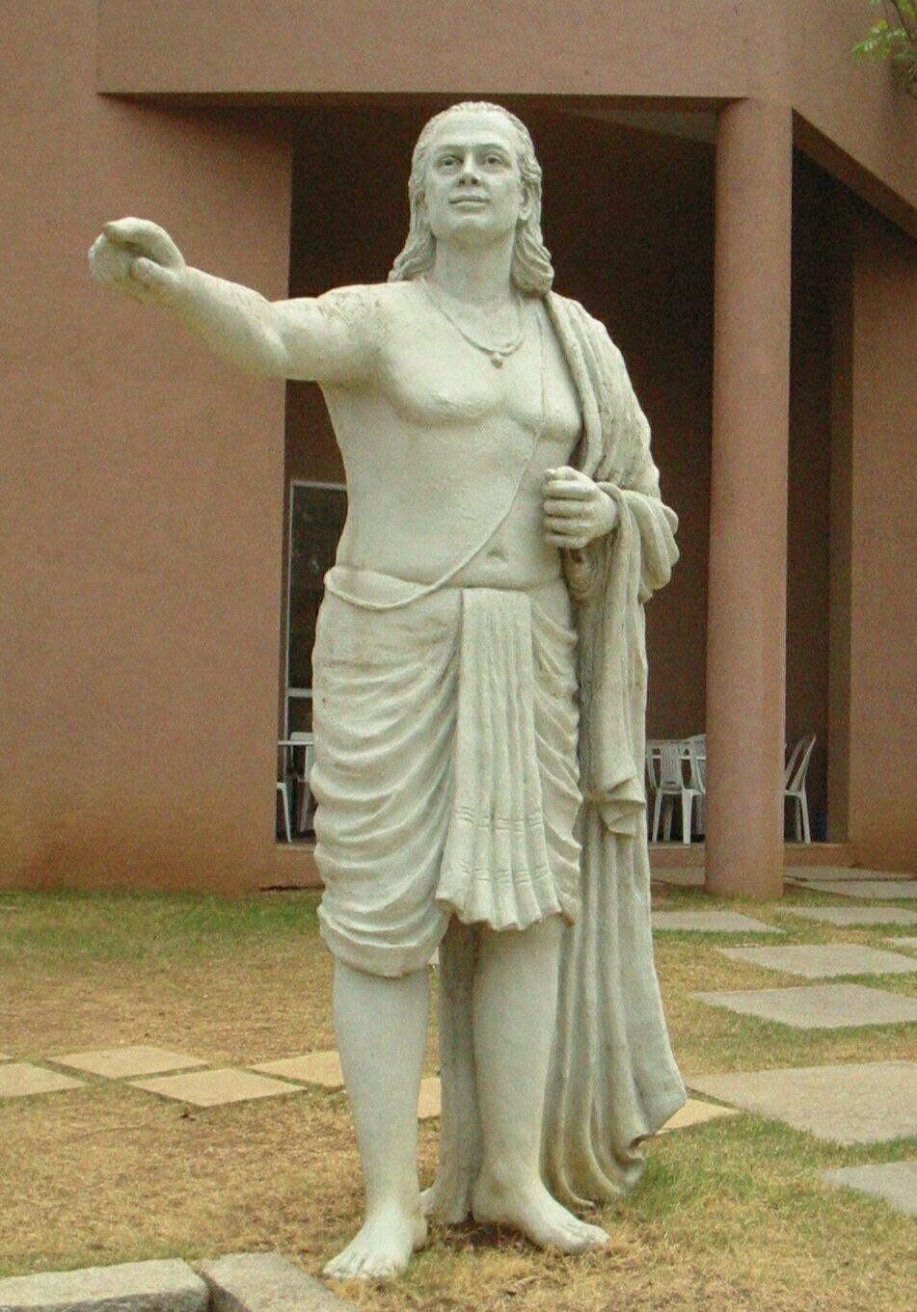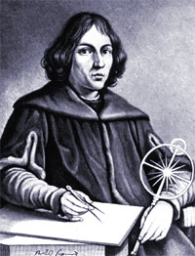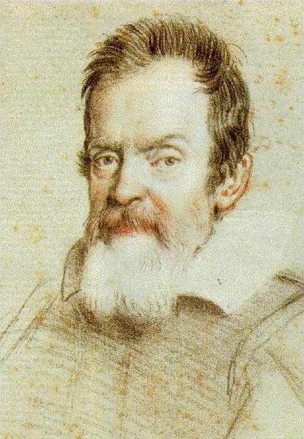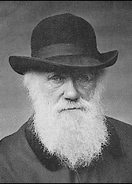

Invocation
LORD of All Creation ~
You have given us Life,
You have given us breath,
You have given us wonder and majesty beyond what our words
and passions can express and
on this day we thank You for
the Sweet Mystery in each corner
of the Universe and in our souls.

CALL TO WORSHIP
adapted from Psalm 104
Leader: O Lord, the infinite variety of your Creation overwhelms us! In wisdom You have made the Universe and the Earth is full of your creatures.
People: Yonder is the sea, great and wide with innumerable living things both small and mighty.
Leader: They all look to You to give them their food in due season.
People: When You give to them, they gather it up and when You open your hand, they are filled with good things.
Leader: When You hide your face, they are dismayed;
People: When You take away their breath, they die and return to dust.
Leader: When You send forth your Spirit, they are created and You renew the face of the ground.
People: May the glory of the Lord endure forever and may the Lord rejoice in the works of Creation!
Leader: I will sing to the Lord as long as I live and I will sing praise to my God while I have being.
All: Bless the Lord, O my soul. Praise and sing to the Lord!

Morning Prayer
O God of All Creation ~ we sing praises to the wonder and majesty of our world. We are small and our individual lives seem so insignificant and yet with our knowledge and skills we have changed the face of our Sacred Home. We pray this day for your Wisdom and Peace, your Patience and Courage to make healthy decisions for the grandchildren of our grandchildren. Open our eyes that we may see all You call us to be.
In the name of the One whose name is Life. ~ AMEN

Scripture ~ Psalm 65:5b-13
5 O God of our salvation; you are the hope of all the ends of the earth and of the farthest seas. By your strength you established the mountains; you are girded with might. 7You silence the roaring of the seas, the roaring of their waves, the tumult of the peoples. 8Those who live at earth’s farthest bounds are awed by your signs; you make the gateways of the morning and the evening shout for joy.
9You visit the earth and water it, you greatly enrich it; the river of God is full of water; you provide the people with grain, for so you have prepared it. 10You water its furrows abundantly, settling its ridges, softening it with showers, and blessing its growth. 11You crown the year with your bounty; your wagon tracks overflow with richness. 12The pastures of the wilderness overflow, the hills gird themselves with joy, 13the meadows clothe themselves with flocks, the valleys deck themselves with grain,
they shout and sing together for joy.

~ SERMON ~
An Informed Faith: the Union of Good Religion and Good Science
How can a Christian resolve the fact that the
Creation in Genesis is so different from
Creation as proposed by evolution?

The Baptist Call of Conscience
Each time I offer a sermon that is in any way controversial, I get this little rush of emotion and pride because we are continuing a process of thinking and living that has been a unique part of our Baptist heritage ever since Roger Williams the patron saint of our denomination ~ if Baptists had saints ~ was kicked out of Massachusetts back in 1638.
And do you know why he was kicked out? He had to leave because he kept preaching the twin heresies of freedom of conscience and strict separation of church and state.
Freedom of conscience is what we Baptists call soul liberty ~ and this is just a shorthand for saying:
your relationship with God and
what you believe is for you to work out.
This means you take all the information gathered in your life and determine the nature of your own beliefs.
You DO NOT simply believe something because your parents tell you, or your friends tell you or the prevailing culture tells you and ~ by all means ~ don’t believe something just because the preacher tells you... what does he know?!? (Hopefully a little…)
Baptists say check it out and ask questions for yourself and then prayerfully make a decision.
Soul liberty ~ it is a cornerstone of what it means to be a Baptist and we are putting it to work today as we do each Sunday.

The Need for Good Science
and Good Religion
I came across a story this week about a little boy who was looking through his grandmother’s big family Bible.
He was fascinated as he fingered through the old pages and suddenly, something fell out of the Bible and onto the floor. He picked it up and looked at it very carefully. What he saw was an old leaf that had been pressed in between the pages many years before.
Granma, look what I found…
the boy called out.
What have you got there, dear?
With astonishment in the young boy's voice, he answered,
I think it's Adam's underwear.
It’s a cute little story that shows how a literal understanding of the Bible can lead to some humorous conclusions.
And if you have been around young children, it’s a way of thinking we can easily understand.
What I’d like us to consider today is taking that same child ten years into the future when he begins to ask questions and, instead of questions based on cute, naïve and partially formed understandings, this young person asks questions based on his own thinking and some of the courses he’s taken in school.
A decade later, this same young person could well ask
Was there literally an Adam and Eve who walked around in a garden and did they get kicked out because they listened
to a talking snake?
The future of that child’s faith and, I believe, the future of religion and spirituality in that child’s life will depend on how we answer that question.
In that instance, we will need to reflect a faith that respects both religion and science. In some people’s minds, Religion and Science are not compatible, they are constantly at war with each other and the truth is, they need not be enemies.

Two Ends of the Debate
What does a faith that respects both science and religion look like?
To answer that question, one person you do not want to ask is Richard Dawkins. Dawkins is an English scientist who has been in the news recently calling for atheists to stand and speak up and become more united.
In a nutshell Dawkins argues that in order for a person to truly appreciate the role of science in the world today, humans need to get rid of their ancient beliefs in God. And these ancient beliefs include
~ a God who is a celestial superpower, vindictive and condemning except with those who love Him
~ a God who is very fussy, needs to be loved and loved only in certain ways,
~ a God who judges our every thought, word and deed,
~ a God who grants or fails to grant our every request and at the end of our lives sends us to heaven or hell based on criteria that we will never really know because there are so many groups of people out there who believe they are the only ones with the truth about salvation.
Dawkins is the spokesperson for that radical fringe which says:
There is simply no room for God
in a world of science.
In my mind, this perspective is just as unhelpful as one provided by Bishop Boniface Adoyo, the head of a group of evangelical denominations in Africa.
The Bishop was in the news recently because the National Museum of Kenya is planning an exhibit that will highlight the fossilized skeleton of what anthropologists call Turkana Boy, the museum’s most prized possession.
Turkana Boy is almost complete skeleton of a 12 year-old boy, estimated to be 1.7 million years old.
Turkana Boy is part of an exhibit showing how modern day humans evolved.
In response to the exhibit, Bishop Ayodo said
I did not evolve from Turkana Boy
or anything like it. These sorts of
silly views are killing our faith.
The Bishop is calling on his flock to boycott the exhibition and has demanded the museum relegate the boy’s skeleton to a back room -- along with some kind of notice saying evolution is not a fact but merely one of a number of theories.
In my mind, the Bishop speaks for the other side of the radical fringe, which believes:
we can only be informed human beings
when we embrace religion not tainted
by any kind of scientific thinking.
Oh… the Bishop may include some science, but you’d have to go to the back room to find it ~ back there with the Flying Spaghetti Monster and other ideas about how life began.
So between Richard Dawkins and Bishop Ayodo, we have laid out the classic battleground for the war between Science and Religion.

Questions Leading to Truth
But there was not always a war between these two. In the Christian faith, for almost 1500 years, the seat of faith and knowledge was the church and the book that provided all the necessary authority and information was the Bible.
All the answers to life’s questions were in there; all of life was explained.
But you know what happened?
There were just too many pesky questions that kept coming up in the minds of too many people, those questions wouldn’t go away and these people just couldn’t keep their mouth’s shut.
There was something about the drive for truth present inside each person that helped pave the way to the understandings we take for granted today.
I have placed four of these scoundrels on our bulletin cover.
Just to review them quickly ~
Aryabhata ~ Indian mathematician from the sub-continent of India, is included here because he is perhaps the earliest person to propose the heliocentric model ~ which means the Earth is not a fixed body but travels around the Sun. He had this idea about a thousand years before Copernicus and is included as a reminder that new ideas are not always new.
Nicolaus Copernicus is next, a Polish astronomer credited with the first modern theory of heliocentrism ~ which says the Earth was only one of several planets that moved around the Sun.
However, Copernicus was afraid to publish his ideas and the story goes that the first published copy of his work was presented to Copernicus on his deathbed and he died peacefully.
No such luck for Galileo Galilei ~ the next picture. When Galileo showed his telescope to the religious authorities, he got responses like this…
[Galileo’s theories] cast suspicion on the
doctrine of the incarnation. [They] upset the whole basis of theology. If the earth is
only one planet among several, it cannot be that any such great things have been done specially for it as the Christian doctrine teaches.
And if there are other planets, since God makes nothing in vain, they must be inhabited;
but how can their inhabitants be descended from Adam? How can they trace back their origin
to Noah's ark? How can they have been redeemed by the Saviour?
You can see how the entire understanding of not just the Bible but all life was in jeopardy with Galileo’s ideas. To me, those statements sound a lot like Bishop Adoyo who wants to keep the skeleton of Turkana Boy locked away in a back room.
And of course the last picture is Charles Darwin, the English naturalist who showed how evolution is responsible for getting you and me right here to this sanctuary today.

Embracing the Seekers
One thing an informed faith does is embrace these outspoken people whose goal is truth and the increase of human knowledge.
Religious people can embrace science because part of being fully human is to allow science and religion to work together. Charles Townes, a 1964 winner of the Nobel Prize in Physics offers this perspective:
Science is an attempt to understand
how the universe works; it tries to discover
how it is that atoms and molecules have come
to form humans and the world they live in.
Religion does not worry about these details; religion attempts to understand the meaning and purpose of our universe, including human life. Yet how the universe works and how it’s constructed must have something to do with that meaning and purpose. Thus, the goals of science and religion are not so far apart;
in fact, they link together the order,
nature, and design of the universe.

The role of Science is to explain
how the world and the Universe operates. It does that by testing and measuring all those parts of our lives that can be tested and measured.
The role of Religion is to explain why the world is set up the way it is, to explore the meaning and purpose of life… which includes all those parts of our lives that cannot be tested and measured. I believe we are weaker when we deny either in our lives.

Science ~ the Source of Wonder
Another thing we can say about an informed life is that it is full of wonder.
Rabbi Abraham Heschel once said:
Humans will not perish because of
a lack of knowledge but because
of a lack of wonder.
Other than the wonder that I experienced at the birth of my children, I get more than enough wonder for each day from websites I check regularly that show pictures from the Hubble Space Telescope of the stars and constellations that fill the heavens. Astronomers offer descriptions of these celestial bodies that sound preposterous and yet there they are, so far beyond our eyes and imagination.
And on a much smaller scale, the wonder of our planet alone overwhelms me. I just installed a new program on my computer that shows a picture of the Earth as seen from the sun. Every minute it rotates slightly and one tiny portion goes into darkness and another comes into the light.
In my mind, I see people on one side of my screen going to sleep and on the other side of the very same screen, I imagine people waking up.
And when Painted Post NY is right on that line and is coming into a new day, I feel like I am part of that big family all along that line between dark and light, looking at a new day and wondering about my existence.
None of this, of course, would be of interest to any person whose thinking was frozen back in the days before Galileo and his telescope ~ almost five hundred years ago.
This means you could be a proud member of the Flat Earth Society ~ an organization known for its complete disregard of any new knowledge science has to offer.
Yes ~ Science has allowed us to live longer and healthier lives but more than that, our lives are richer and more wondrous with more opportunities to knock our socks off everyday.
Please remember, an informed life is filled with wonder and no one needs fancy websites to know that’s true ~ wonder is all around us everyday.
It is my belief that the wars would not be fought if our leaders had more awe and wonder in their lives and appreciated the sacred quality of each human and all life on this jewel in space we call the Water Planet.

Allowing the Bible to be an
Informed Authority
Finally, Christians with an informed faith give the Bible a real authority in their lives.
Those religious leaders who told Galileo five hundred years ago that the entire church would fall apart if people believed the Earth went around the Sun were just as wrong, I believe, as Bishop Ayodo who says displays like Turkana Boy are destroying our faith.
I believe what is destroying our faith is being shackled to a literal interpretation of the Bible that insists on everything being provable.
The Bible, a collection of sixty-six books and written by way more that sixty-six people and collects stories that describe an on-going relationship with God over hundreds of years.
The books were put together in order to pass those stories along to future generations ~ to you and me.
The Psalms, like the ones we read today offer images of a God who waters the Earth and makes mountains; they are images of a God described by people who had no desire or need to provide accurate history or scientific details.
The stories are about love and compassion and forgiveness and peace and joy ~ Remember ~ all those things that cannot be measured by Science.
When we try to impose a scientific understanding on subjects that have nothing to do with Science, we get in trouble.
For example, in order to convince me otherwise, people regularly tell me that they know of a scientist who has figured out that all the animals in the world, two of every kind, would have been able to fit on the ark built exactly as described in the Bible. Hearing those words, I say to myself
we are missing the
main point of the story.
It is simply not necessary to figure out and prove how Noah and his family stored all the food or why the lions didn’t eat the zebras or how Noah got animals from all over the world and… the first question on every kid’s mind:
Where did everyone go to the bathroom?
When we spend our time trying to answer those kinds of questions, we miss the message of God’s compassion and care for all Creation and we miss the part about forgiveness and hope. What’s more important? That the story have scientific accuracy or the truth the story reveals about God?
I am reminded of Black Elk, a Native American who began all his stories by saying:
I don’t know if this is exactly how this story happened, but I know it is true.
When the Bible is a real authority ~ an authority informed by modern thought ~ it no longer has to be an accurate word for word in every area of science and history.
A real authority means that the truths in the Bible stories will be true no matter what science learns about our Bible or our world or this Universe.
Imagine a space flight in a few years that includes landing on a planet a few hundred light years away.
In that situation, with all the knowledge and technology that allows such a feat to happen, I believe stories of God’s Way of Love will still ring true.
The rich young ruler comes to Jesus and asks:
What is the greatest commandment?
And Jesus answers:
To love the Lord your God with all your heart, soul, mind and strength and
your neighbor as yourself.
The truth of those words can never be undone, no matter what discoveries Science makes.
Today we are invited to let Science into our lives and do ALL it wishes ~ to enhance our knowledge and fill us with wonder.
Today we are invited to let the Bible be the Book of Abundant Life all of its inspired writers dreamed it would be. AMEN

Turkana Boy Online: You don’t have to go all the way to Kenya to see Turkana Boy and the display on Human Origins. The day after I delivered this sermon, an online tour was made available of the newly refurbished Hall of Human Origins at the American Museum of Natural History in New York City on the website of the New York Times. Just google “NY Times video Hall Human Origins”

The Four Pictures on Page 1 ~ were on the February 11 bulletin and are from the online encyclopedia wikipedia.com. Aryabhata ~ Indian mathematician, 476-550; Nicolaus Copernicus ~ Polish Astronomer, 1473-1543; Galileo Galilei ~ Italian astronomer, 1564-1642; Charles Darwin ~ English naturalist,
1809-1882.

This is an excellent overview of a growing and vocal atheism within the scientific community and our modern culture. http://www.wired.com/wired/archive/14.11/atheism.html
Is God a Delusion?, Neale Donald Walsch, ODE Magazine, pg 61, March 2007
Ancient Boy’s Skeleton Sparks Evolution Debate http://www.cnn.com/2007/TECH/science/02/06/kenya.fossildebate.ap/index.html
Please forgive this blatant attempt to sneak in one of my favorite parodies on the evolution of life. Take the tour and visit Church of the Flying Spaghetti Monster ~ http://www.venganza.org/. I didn’t have time to explain further in this sermon but felt called to spread the word of the FSM and his invisible noodly appendages which embue all creation with the life force.
A History of the Warfare of Science with Theology in Christendom, The War on Galileo; http://www.cscs.umich.edu/~crshalizi/White/ astronomy/war.html
From an article in Science and Spirituality: Marriage of Two Minds by Charles Townes, Nobel Prize in Physics, 1964; http://www.science-spirit.org/printerfriendly.php?article_id=576
I first heard this quote in a lecture by Matthew Fox and can honestly credit him with this entire section of the sermon. More than anyone, Matthew Fox opened my eyes to the need for Christians to “read” the wonder and beauty of Creation. He makes the point Creation was the “text” for many writers of the Hebrew scriptures; modern day Christians have simply lost that skill.
It’s called OSXPlanet, is free and can be downloaded from http://www.gabrielotte.com/ osxplanet/main.html
Introduction to the Flat Earth Society ~ http://www.theflatearthsociety.org/forums/viewtopic.php?t=1324 ~ and ~ The Earth is Not a Globe by Samuel Birley Rowbotham http://www.sacred-texts.com/earth/za/index.htm

