Darwin Day celebrations evolve with parties, proclamations
Kimberly Winston | Feb 11, 2014

(RNS) Happy Darwin Day! A time to play pin the tail on the sparrow, partake of “phylum feasts” (potluck dinners where the ingredients come from many different species), and generally give a thumbs-up to evolution’s godfather, Charles Darwin, on his 205th birthday, Wednesday (Feb. 12).
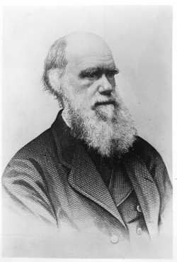
Charles Darwin (1809-1882), author of “On the Origin of the Species.” Religion News Service file photo

A growing number of Americans of varied religious backgrounds are marking the 1809 birthday of the British naturalist whose masterpiece “On The Origin of Species” has never been out of print since its publication in 1859.
Consider:
- Rep. Rush Holt, D-N.J., introduced a resolution to the U.S. Congress last month, asking that it recognize Feb. 12 as Darwin Day, the third year a congressman has done so. Cities from San Diego to Omaha, Neb., have made similar local proclamations.
- Zazzle and Cafe Press offer Darwin Day cards. Samples: “I naturally select you” and “Let’s evolve together.” Can Hallmark be far behind?
- According to the International Darwin Day Foundation, over 90 groups of atheists, humanists and other freethinkers are holding local celebrations that run from potluck dinners (the so-called phylum feasts) to nature outings, lectures, book discussions and film screenings.
- Almost 600 congregations addressed the relationship between religion and science as part of the annual “Evolution Weekend,” which occurs on the weekend closest to Feb. 12.
- This year, HBO got into the spirit with “Questioning Darwin,” a new documentary that is part Darwin biopic, part examination of the minds and lives of American creationists.
“I put Darwin up there in my pantheon with the greatest prophets and disciples,” said Antony Thomas, the British director of “Questioning Darwin” and other films about religion. “I think he has done more to contribute to our understanding of who we are and our place in this universe than anybody else.”
Darwin Day is a British invention, begun not long after the scientist’s death in 1882. The first large, formalized gatherings occurred in 1909 with celebrations in London, New York and New Zealand.
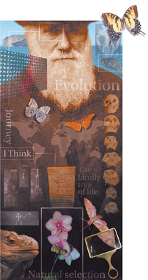
(RNS) Illustration depicting the life and influence of Charles Darwin, the Bible-carrying Anglican who advanced the theory of evolution. RNS file illustration by Andre Malok/The Star-Ledger of Newark, N.J.
While scientists organized the first celebrations, humanists, atheists and others soon entered the mix. The Humanist Community of Palo Alto is thought to have marked the first Darwin Day in 1994 and today the American Humanist Association maintains the International Darwin Day Foundation and helps organize events worldwide.
Religious groups have also called for commemorating the day. The Clergy Letter Project, initiated in 2004, has garnered over 13,000 signatories — Christian, Jewish, Buddhist and Unitarian Universalist — to a letter that calls evolution “a foundational scientific truth.” The project eventually led to the formation of Evolution Sunday, which later became Evolution Weekend.
And while a majority of Americans say they support the idea of evolution — 60 percent, according to a 2013 Pew Research Center poll — not everyone will be trumpeting Darwin’s insight. Several years ago, the Defending Genesis ministry issued a “Creation Letter Project” that stated, in part: “Evolution is a lie which undermines both Biblical authority and the foundational basis of the Gospel.” It has about 300 signatories.
“If you accept an all-natural scientific origins as truth you will chuck the spiritual truth that is attached to the supernatural origins of the world in Genesis,” said Tony Breeden, Defending Genesis’ founder and author of its letter on creation.
And then there’s “Question Evolution Day,” also slated for Feb. 12, organized by “Cowboy” Bob Sorenson. Sorenson, a blogger, wants his fellow creationists to question Darwin’s theory in print and online forums.
“We can question evolution every day,” his website says.

