Mother Nature Network

5 common myths about evolution [Infographic]
The ongoing 'debate' about evolution relies heavily on popular misconceptions. A Ph.D. student in biology created this infographic to clear up five persistent fallacies.

Fri, Feb 07, 2014 at 3:42 PM

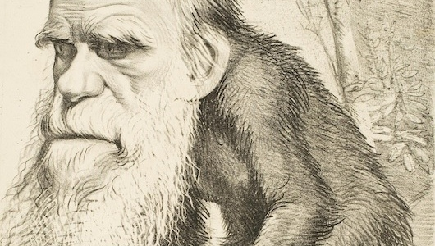
An 1871 caricature portraying Charles Darwin with the body of an ape. (Image: Wikimedia Commons)
This is Evolution Weekend, a spinoff of Darwin Day created to raise awareness that — contrary to a common misconception — biological evolution isn't a threat to religion.

That misconception is actually based on a series of popular fallacies about what evolution is, how it works and why it's so widely accepted. Breaking down such confusion is an important step in boosting U.S. scientific literacy, and it's not as daunting as it might seem. We recently highlighted two animated videos that explain evolution simply and entertainingly, but not everyone has time for 15 minutes of cartoon science lessons.

So, for an even more digestible debunking of evolution myths, we can thank Purdue University biology Ph.D. student Caleb Trujillo for creating the infographic below, "Top 5 Misconceptions About Evolution." Originally posted on Trujillo's Tumblr page, Molecular Life Sciences, it has accumulated more than 7,000 Tumblr notes in the past week alone.

At least 574 congregations around the world will observe Evolution Weekend this year, hoping to bridge a needless gap between science and religion. As Trujillo points out, "Evolution does not explain what started life, only how it persists, adapts and changes."

