Medill Reports - Chicago

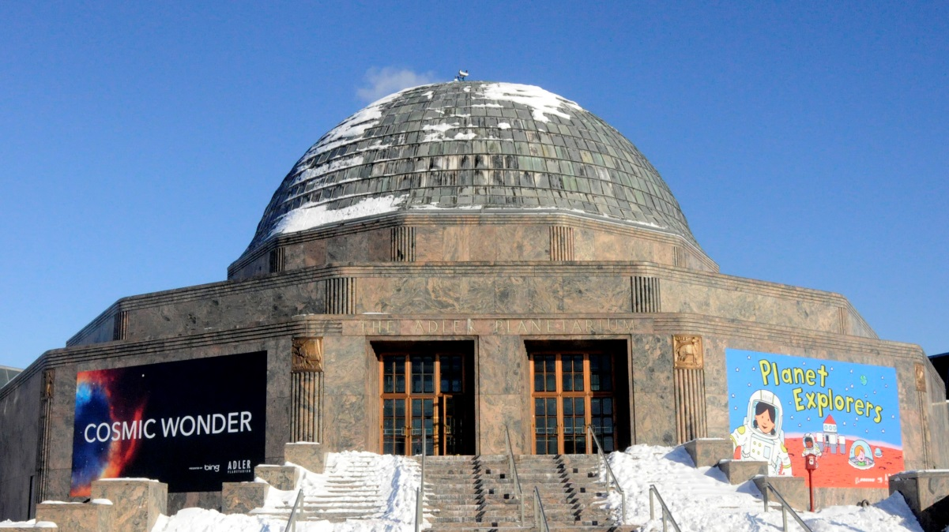

Laura L. Calderone/MEDILL
Adler Planetarium will host "Clergy Contributions to Science," an event covering how clergy members and religious institutions have participated in scientific discovery. The event will be held Feb. 18 with poster displays and social media interaction available for the public.

Adler Planetarium asks: Can science and religion coexist?

by Laura L. Calderone
Feb 12, 2014
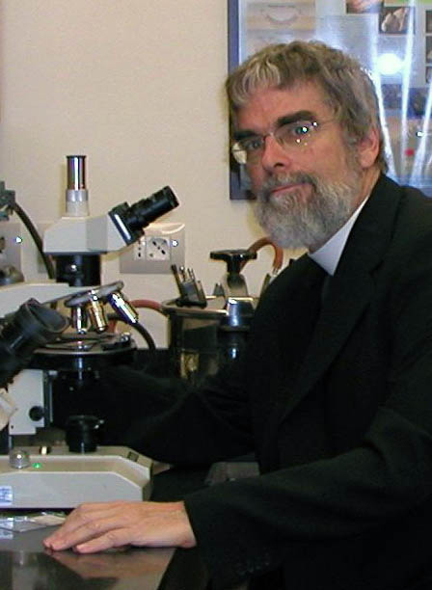
Brother Guy Consolmagno/Vatican Observatory
Brother Guy Consolmagno is an astronomer and curator of the meteorite collection at the Vatican Observatory. He will be speaking at Adler Planetarium’s "Clergy Contributions to Science" event on Feb. 18.
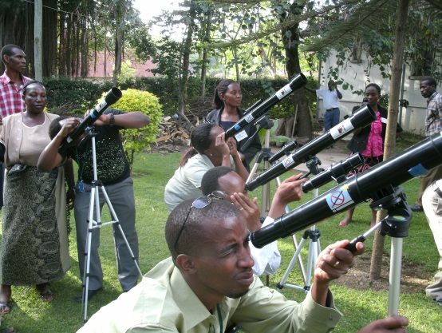
Telescopes to Tanzania
Students and teachers use telescopes to gain an understanding of science and astronomy as part of Telescopes to Tanzania. Retired pastors Chuck and Susan Ruehle, of Racine, Wis., started this project. The organization will have a display at Adler Planetarium’s "Clergy Contributions to Science" event on Feb. 18, 2014.
Just call him brother, but he used to go by prof.
Brother Guy Consolmagno began his career in astronomy at the Massachusetts Institute of Technology and later became a professor at Lafayette College in Easton, Pa., until everything changed at the age of 40.
“It was a classic midlife crisis,” said Consolmagno. “I was teaching at Lafayette College and really enjoyed it. I loved the school and I loved being a professor. But, there was one thing missing. A sense of doing something bigger than myself.”
That was when he decided to take his vows, but instead of returning to teaching, he received the opportunity to become an astronomer and curator of meteorites at the Vatican Observatory.
Consolmagno is one of many clergy members who will be attending Adler Planetarium’s “Clergy Contributions to Science” event on Feb. 18. The program is designed to elicit conversation about the ways in which religion and science can coexist. It will also raise awareness that members of clergy have made many contributions to scientific discovery throughout history, said Grace Wolf-Chase, an astronomer at Adler Planetarium.
“There are a lot of people for which both science and religion coexist comfortably. In fact a lot of people find that science can be enriching to their religious faith,” she said. “So the idea for this was that we would show not just that clergy support science but that many clergy have made central contributions to science.”
The event is occurring in the wake of the Clergy Letter Project’s Evolution Weekend, which took place from Feb. 7-9, and Charles Darwin’s birthday, Feb. 12. The Clergy Letter Project and Evolution Weekend are designed to educate the public about the ways religion and science are not in serious conflict, according to the organization’s website.
“This is to raise awareness,” she said. “The goal here is to help break down barriers and help build communities of trust because there’s too much negative messaging out there. We’re trying to send a positive message that we can be partners. This doesn’t have to be what you hear, which is science versus religion as opposed to the communities working together to the benefit of everybody.”
It’s about understanding there’s not really the conflict that is often perceived.
“Too often it’s viewed as dichotomy of the church versus science,” said the Rev. Chuck Ruehle, a retired Evangelical Lutheran Church of America pastor from Racine, Wis. He is the co-founder of Telescopes to Tanzania.
Telescopes to Tanzania is a non-profit organization that works with teachers in Tanzania to educate students about the sciences and astronomy. The organization was started by Ruehle and his wife Susan, also a retired pastor.
The theologians who will attend the event seem to agree: Science and faith not only can cooperate but also can deepen understanding of both. What drew the theologians to careers in faith and science was their sense of curiosity and awe in both.
“Part of what really drew me into science and a vital part of my faith was a sense of awe and wonder. There is so much more to this life that we can ever truly know,” said the Rev. Bruce Booher, pastor of First Lutheran Church in Plano, who holds astronomy retreats for people of faith. He felt a deepening of his faith while an undergraduate in astronomy at the Massachusetts Institute of Technology. He is a member of the steering committee of the Lutheran Alliance for Faith, Science and Technology.
The presentations will be for invitees only, but the public will be able to interact.
Members of the public can view signage highlighting clergy contributions made in the past. There will also be activated social communities to bring an online presence to the event, said Nicholas Glenn, an Adler spokesman.
If visitors want to participate in the discussion on Twitter, they should use the hashtag #Science4Everyone, said Wolf-Chase.
There will also be poster display of Telescopes to Tanzania, so people can learn more about the organization.
Museumgoers can see Consolmagno as part of the “Current Space News” program at Adler at 11:05 a.m. Feb. 18. He will talk about his research on meteorites and asteroids, such as the meteorite that broke up over Chelyabinsk, Russia in 2013.

