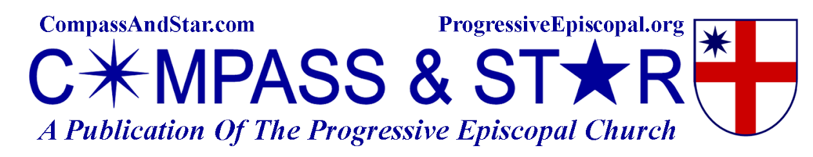

Friday, January 31, 2014

Evolution Weekend 2014: religion and science are not adversaries
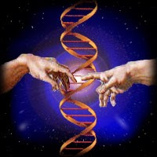
EVOLUTION WEEKEND: FEBRUARY 7-9, 2014

Evolution Weekend is an opportunity for serious discussion and reflection on the relationship between religion and science. An ongoing goal has been to elevate the quality of the discussion on this critical topic, and to show that religion and science are not adversaries. Rather, they look at the natural world from quite different perspectives and ask, and answer, different questions.
Religious people from many diverse faith traditions and locations around the world understand that evolution is quite simply sound science; and for them, it does not in any way threaten, demean, or diminish their faith in God. In fact, for many, the wonders of science often enhance and deepen their awe and gratitude towards God.

Learn more, gather resources and participate here...

