The Citizen, Auburn, NY

Evolution Weekend: Religion and science, not in conflict
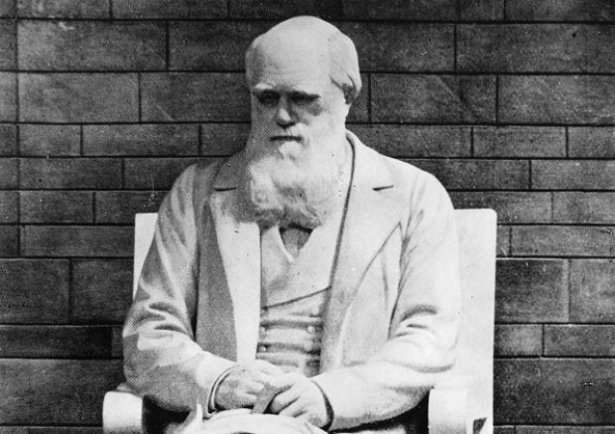
AP
Undated image of the statue of British scientist Charles Darwin, pictured at the Natural Museum in London, England. (AP Photo)
February 02, 2013 3:15 am • Howard Nelson, Special to The Citizen
(0) Comments
Since 2006, mid-February has been a time, in churches and synagogues across the nation, for an observance affirming the idea that religion and science are compatible, and that the theory of evolution in particular is not a threat to religious faith. Originally designated Evolution Sunday, it was renamed Evolution Weekend to be more inclusive of various faiths with their different sabbaths. This year, Evolution Weekend will take place Feb. 8-10, and it will be observed by hundreds of congregations from many different denominations and traditions.
Evolution Weekend had its origin in the Clergy Letter Project, begun a few years earlier by biologist Michael Zimmerman, as a response to initiatives by some religious leaders and groups on behalf of teaching biblical creationism in public school science curricula, and of treating evolution as merely “one theory among many.” Zimmerman’s campaign rapidly gained support from members of both the clergy and the scientific community. They endorsed the letter to express solidarity with the idea that “science and religion are different but complementary forms of truth.” The letter went on to say, “Religious people from many diverse faith traditions and locations around the world understand that evolution is quite simply sound science; and for them, it does not in any way threaten, demean, or diminish their faith in God. In fact, for many, the wonders of science often enhance and deepen their awe and gratitude towards God.”
Here in Cayuga County, Poplar Ridge Friends (Quaker) Meeting has participated in Evolution Weekend for several years now. On Evolution Weekend, we hold our meeting for worship in our usual format, which includes some singing, a reading, a message from our pastor or other members, and a period of silence during which anyone may speak as led by the spirit. We simply make the theme of our worship that day the relationship between science and religion, and this may take us in a variety of directions. Sometimes a member who has some special background in science has brought the message. We have heard from a geologist, a physicist, a geophysicist — and each has brought special insight. But it isn’t necessary to have a scientist in order to participate. Any clergy or lay person might reflect on the relationship between science and religion, or other ways of acknowledging the theme might be found — for example, through inspirational readings or songs that celebrate the beauty and wonder of nature. Any faith group wishing to affirm and reflect upon the relationship between science and religion is welcome to join the list of participants simply by registering online at www.evolutionweekend.org.
Why February? The date was chosen to be the weekend closest to the birthday of Charles Darwin. Darwin knew his ideas would be met with resistance, which they certainly were, and in some quarters continue to be. Speaking personally, I find it exciting and enlightening when science and religion enter into dialogue, like two interesting, open-minded people. Darwin was courageous when he published his findings, telling the truth as he had observed and conceived it. I am one of those who feel that, however controversial his ideas have been, his way of seeing creation is no less beautiful or amazing than the accounts we find in Genesis. In the closing words of "On the Origin of Species," Darwin was clearly expressing what someone else might call reverence or religious awe: “There is grandeur in this view of life, with its several powers, having been originally breathed by the Creator into a few forms or into one; and that, whilst this planet has gone cycling on according to the fixed law of gravity, from so simple a beginning endless forms most beautiful and most wonderful have been, and are being evolved.”
Most scientists believe that creationism does not belong in the science classroom. On the other hand, churches, synagogues, and mosques are really good places for the rich and enriching, mutually respectful conversation between religion and science to take place.
Howard Nelson is a professor of English at Cayuga Community College in Auburn.

