Sarasota Herald Tribune

Creationist says science led him to beliefs
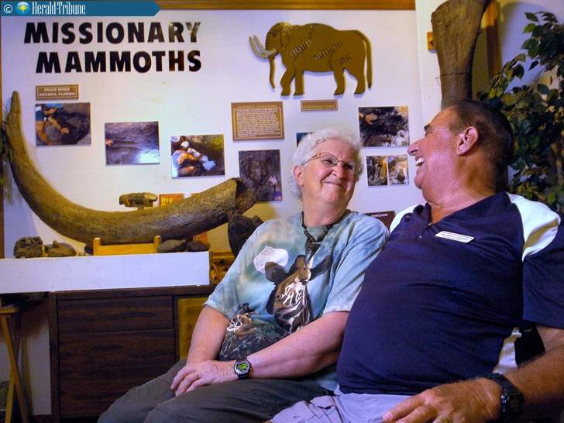
Mary and Gary Parker started Creation Adventures Museum from their home in Arcadia. The museum promotes the belief that the earth is about 6000 years old, a timeline the Parkers say is consistent with the Bible.

By Billy Cox

Published: Monday, December 12, 2011 at 2:56 p.m.

Last Modified: Monday, December 12, 2011 at 2:56 p.m.

ARCADIA - In 2000, long before creationism advocates erected a $27 million state-of-the-art showcase in Kentucky, Gary Parker, with significantly fewer resources, established his own platform for telling visitors how dinosaurs lumbered off Noah's Ark.
Set in the modest home he shares here with Mary, his wife of 49 years, Parker's non-profit Creation Adventures Museum has an ideal location, a mere five-minute walk from the fossil-rich Peace River. The low-tech museum shares the folksy demeanor of its creator, whose lecture-room walls are lined with biblical-flood dioramas and nearly a score of folding metal chairs awaiting the next batch of visitors.
The centerpiece of the display is a cast of an elephant femur recovered, like many other fossils here, from the river. Parker, an affable and enthusiastic host, calls it "our missionary mammoth" because it provides the visual entree to his contention that the relic, like planet Earth itself, can be no more than 6,000 years old.
"There's nothing that gets young people stimulated by science more than a hands-on experience," Parker says of his guided field trips to the river. "When you get out there and dig and identify fossils, you can really see how science works."
Parker's use of the word science to advance a scriptural argument that God created the Earth without a 4.5 billion-year assist from evolution rankles mainstream scientists. But the 71-year-old author and retired Christian college professor has support.
In a 2010 Gallup Poll, 40 percent of Americans indicated they believe God created humans in present form. That's down from 44 percent when polling on creationism began in 1982. But the 38 percent of Americans who think humans evolved with God's stewardship has remained constant for 29 years.
By contrast, Gallup discovered that a mere 16 percent of those polled thought evolution proceeded without divine intervention. However, that's nearly double the 9 percent who believed solely in evolution in 1982.
Exactly how creationist museums move those numbers is uncertain.
Glenn Branch of the National Center for Science Education, Inc., in Oakland, Calif., identifies four museums in Florida — Parker's in Arcadia, as well as others in Key West, Pensacola and Fort Lauderdale.
But none, he says, have succeeded in energizing the debate like the 70,000 square-foot Creation Museum colossus in Petersburg, Ky.
Founded in 2007 by the Answers in Genesis ministry — which "seeks(s) to expose the bankruptcy of evolutionary ideas" — the headline-grabbing Creation Museum maintains exhibits that, among other things, show dinosaurs and humans living side by side. But its brazen and interactive features, which include a planetarium, are only the latest manifestations of a phenomenon with early 20th-century roots.
Branch, whose Science Education network emerged in 1981 to champion evolution over creationism, says creationist museums began springing up in the 1920s, when organized opposition to teaching evolution culminated in the landmark Scopes "Monkey Trial" case in 1925. But he suspects their current incarnations are driven by a larger movement.
"I wouldn't be surprised if a lot of visitors were homeschoolers or from Christian schools," Branch says. "The whole existence of creationism belongs to the counterestablishment trend of opting out of government-supported education and insulating themselves from secular influences."
A 2009 doctoral analysis of creation museums by Harvard student Julie Ann Duncan forecasts an expansion in the struggle for hearts and minds: "It seems very probable that the years to come will see the construction of more museums, most likely in the high-tech style of the Answers in Genesis Creation Museum, which has proven quite lucrative."
In Arcadia, though, Gary Parker calls himself a former evolutionist who didn't need a museum's influence for a conversion.
He says evolution simply flunked his standards for evidence.
Having earned a biology/chemistry degree from Wabash College (Ind.) and an education doctorate in biology from Ball State, the Arcadia native says he was raised in a family with no rigid doctrinaire beliefs and attended church on holidays. Parker insists science itself led him to conclude there were irreparable holes in radiometric dating used to assess the age of rocks.
"I had been led to believe the Bible was just another book with a happy ending like all those other fairy tales, and that Jesus was just another important teacher who held out hope but couldn't deliver," says Parker, an adjunct professor with the 41-year-old, Dallas-based Institute for Creation Research, which teaches the biblical accounts of Earth origins. "But the more I looked into it, the more I began to wonder if maybe God really did write a book that laid it all out."
Parker made a 40-year career of teaching college-level biology, most recently at Clearwater Christian College. Today, visitors to his Creation Adventures Museum — a repository for impressive megalodon teeth, mastodon tusks and fragments of giant ground sloths, among other things — can get guided instruction on how to retrieve their own specimens from the Peace River.
For $15 each, guests attend introductory workshops, venture into the river, and log whatever specimens they find, as required by state regulations, for the Florida Museum of Natural History.
The workshop concentrates heavily on the museum's diorama scenes, which illustrate what Parker calls "the four Cs": God's Creation was ruined by man's Corruption, which was subsequently eradicated by the Catastrophe of Noah's flood, then redeemed by Christ.
Under this scenario, all life was created simultaneously. Parker says creatures annihilated by the Old Testament flood, like most dinosaurs, were victims of geography, not chronology.
"There were some dinosaurs that got off the Ark," he says. "Where they migrated to depended largely on their source of food, which caused a lot of them to make a wrong turn, like to the north slope of Alaska." The remains of extinct species found in the Peace River, he says, were likely deposited by "post-flood" forces.
Although fossils can be found the length of Florida's peninsula, Tom DeRosa of the Creation Studies Institute in Fort Lauderdale likes to bring field trips to the Peace River's "unique testimony" of clear shallow water. He says the most recent polling on creationism "shows you clearly that the brainwashing of evolutionary teaching has not been very successful."
University of Florida geologist Joe Meert says he is still waiting for creationists to get young-Earth research published in refereed science journals.
"But where the rubber really meets the road is when you look at oil and mining companies who use radiometric dating to find major deposits, because it works," Meert says. "They don't use Noah's flood models, because they have to make profits."
On the other hand, Meert says he does not see evolution doomed to a collision course with faith: "Most people who have religious beliefs and think God created life on Earth really don't care when it happened."
Indeed, at last count, 12,760 multi-denominational clerics have endorsed the pro-evolution Clergy Letter Project, which advocates banning creationism in public schools. The movement was started in 2004 by Michael Zimmerman, a biology professor at The Evergreen State College in Everest, Wash.
"Creationism is incredibly well funded and the polls have remained stagnant for years," Zimmerman says. "What you've got are strident voices on the margin trying to appeal to the mainstream. I can't tell you how many clergy I've talked to who've signed the Letter Project and told me, 'I thought I was alone.'"
But for 41-year-old Will Zinke, who began an enduring friendship with Parker while reading several of Parker's 15 books as a student at Clearwater Christian College, creationism is central to his spirituality.
"I thought, well, if Genesis wasn't true, how can I trust the rest of the stories in the Bible?" he says.
The son of missionaries, Zinke briefly raised his young family in Kenya, has a biology background, and is an avid amateur paleontologist. His three home-schooled children are experts at identifying Peace River fossils, and he moved them to Arcadia with an agreement to take over the Creation Adventures Museum after Parker retires.
When that happens, Parker says, his own creation will be in good hands, because he and his former student see eye-to-eye on the future.
"I hate to say it," Parker says, "but evolution has given science a bad name."

