Newsmax

Million Set to Watch Online Creation v. 'Science Guy' Showdown
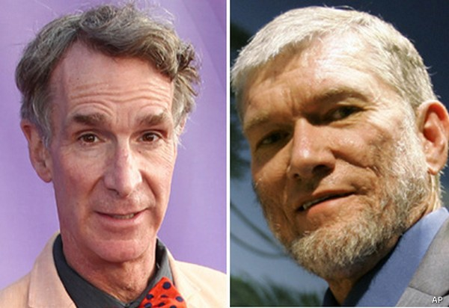Bill Nye, left, and Ken Ham
Monday, 03 Feb 2014 11:34 AM
By Drew MacKenzie

More than a million online viewers are expected to watch a face-off Tuesday night between Ken Ham, president of Answers in Genesis, and "Bill Nye the Science Guy."
The debate will pit the theory of creationism against scientific claims about the foundations of life on earth, with followers of both sides hoping for some form of definitive proof that their case has more weight, according to USA Today.
The "Evolution Weekend" event is being staged by The Clergy Letter Project at the Creation Museum in the tiny hamlet of Petersburg, Ky., and it is being called the biggest spectacle in the 20-year history of Ham's creationist ministry, which he still runs today.
The museum plans to livestream the event free at 7 p.m. Eastern Time Tuesday at debatelive.org.
Australian-born Ham said that he's feeling a "little fear and trepidation" and "a little stress" before the debate because it has attracted enormous interest. But he expects to win because he has the Lord on his side.
"The way I work, I can do my best in convincing people because I don't have to do the convincing. God does the convincing," Ham said.
And Nye is hoping that even if adults don't get his scientific message, their children will.
In a video posted online, Nye said, "I say to the grown-ups, if you want to deny evolution and live in your world — in your world that's completely inconsistent with everything we observe in the universe — that's fine. But don't make your kids do it, because we need them."
But Michael Zimmerman, founder of The Clergy Letter Project, believes that ultimately there will be no winner in the debate, although he noted that it will make "for good theater."
"Nye has said that he doubts the debate will change the minds of any creationists. I suspect he's correct about that. Unfortunately, this debate ... will lead people to think that evolution and creationism have equal standing, and that there's something significant to debate," Zimmerman said.
More than 800,000 people had registered to watch the debate live online two weeks before the event.
Nye, who is said to be receiving an appearance fee of around $50,000, has been previously criticized by officials at Creation Museum because they claim he had "stepped outside of observational science" by warning that teaching creationism was bad for kids.
Created in 2007, the museum attracts 250,000 people a year, and the cash it generates has helped to build a $60 million Noah's Ark biblical theme park in nearby Grant County.
Although Ham's ministry has been attacked by the secular world and church leaders alike, he contends that he's just "trying to get information out to the culture that ... has been censored."
He added, "We certainly believe students should be allowed to critically analyze evolution. You can't really believe both because it's not consistent with the Bible. You can't add millions of years to what the Bible teaches."

